Assiut University
Faculty of Medicine
Dept. of General surgery

CURRICULUM VITAE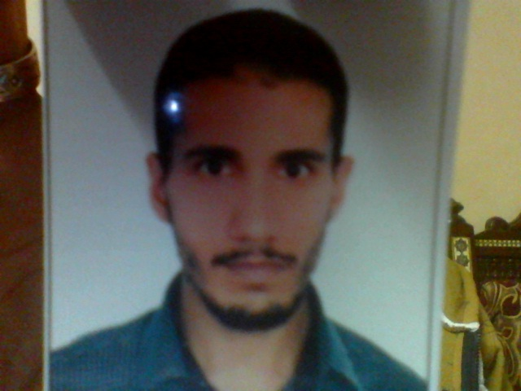

Hesham Fayek Fouad Soliman
Assistant lecturer of General surgery,
Assiut University Hospital,
Assiut, Egypt

Office(+2088)2413280
Fax: (+2088)(2334541)
Mobile: (+2)01114554571

Personal data | First name Hesham  Middle names :Fayek  Last name (Family or Surname): Soliman  Tel:  Mobile : +2 01114554571  00201063059623  Email : hesham.surgeon@yahoo.com  Date of birth :5 october, 1983.  Marital status : Married.  Nationality : Egyptian.  Address : Egypt, Assiut, taqseem elmoalemeen No.247  Correspondence: Egypt, Assiut, Assiut University Hospital, Department of General Surgery,. Assiut, Egypt  Current hospital: Department of General Surgery,. Assiut University Hospital, Assiut, Egypt.  Non-medical interests: Sports (football) and reading novels.  Languages : Arabic, English .
Current position | Assistant lecturer of General paediatric Surgery, Assiut University Hospital, Assiut, Egypt (4/7/2012 till now).
Positions held | House officer: Assiut University Hospital (1/3/2008-28/2/2009).  Resident (General Surgery): Assiut University Hospital (1/3/2009-3/7/2012).
Qualifications | High school diploma (basic education): Al Maad el deeni secondry school Dubai UAE (1999-2001).  MB.Bch: Faculty of medicine, Assiut University (9/2001-9/2007) (Excellent with honor).  M.Sc. in General Surgery: Assiut University Hospital (22/4/2009-10/11/2012). [2]  Ph.D in General surgery: Assiut University Hospital (04/4/2012- uptill now)
Professional licensure | Egyptian ministry of health
Clinical Experience | During my work as a house officer, as a resident and as an assistant lecturer, I gained experience in the following activities:  (High experience in all the following :)  - Minor surgical maneuvers,  - Out-patient clinical management,  - In-patient clinical management,  - Management of traumatized patients,  - Emergency surgery, in the emergency surgery unit of my department concerned with the reception of cases like intestinal obstruction and acute abdomen and in addition, in the trauma unit in my university hospital,  - Elective open surgery including:  - Hepato biliary surgery: Cholecystectomy, exploration of the common bile duct, hepatico-enterostomy ,major liver resections, liver biopsy, pancreatico-duodenectomy,  - Colorectal surgery: various types of colectomies, anterior resection, abdomino-perineal resection,  - Endocrine surgery: various types of thyroidectomies, parathyroidectomy,  - Head and neck surgery: parotid sialadenectomy, submandibular sialadenectomy, thyroglossal cyst excision, excision of neck swellings,  - Breast surgery: breast biopsies, conservative breast surgery, axillary dissection, Patey’s operation and its modifications,  - Anorectal surgery: peri anal fisula ( low and high), pilonidal sinus, anal stenosis, haemorroids, anal fissure,  - Oncology Surgery: Colorectal cancer, ampullary and peri-ampullary tumours, breast cancer, thyroid cancer, salivery gland tumours,  - Groin and Ventral hernia operations,  - Others: splenectomy, mesenteric cyst, resection anastomosis.  - Laparoscopic Surgery:  - Diagnostic laparoscopy,  - Laparoscopic cholecystectomy.  .
Graduate, post graduate training, courses and conferences attended | 2001-2007: Graduate studies; Faculty of medicine, Assiut University.  2008-2009: House officer; Assiut University Hospital.  2009-2012: Resident; General Surgery dept., Assiut University Hospital.  2010 : Laparoscopic surgery training course, organized by Mostafa Hamad, MD;  Assiut University Center for Endoscopic Surgery Training (AUCEST),  Assiut University Hospital (basic).
Teaching activities | Supervising house officers since March, 2009.  Supervising the work of residents since December, 2011.  Involved in undergraduate student teaching since March, 2012.
Referees and references | [1] Assiut University was inaugurated in 1957 to encourage research, education and  community services in Upper Egypt. It is located in Assiut City which is 375  Km south of Cairo, the capital. The university comprises sixteen faculties and  two higher institutions. PO Code No. 71515, Egypt. http://www.aun.edu.eg  [2] Assiut University Hospital is one of the biggest University Hospitals in Egypt. It  is the core referral center for the whole Upper Egypt that serves about twenty  million people. The hospital contains 2027 beds, including 94 ICU beds, and 46  operative theaters in which 240 operations are performed daily. 1478 medical  and 6428 paramedical staff serves in this hospital. 3000 patients visit the  outpatient clinics and 1000 are received in the emergency departments daily.  The department of General Surgery contains 420 beds, including 98 beds in six  specialized units: Laparoscopic Surgery unit, Pediatrics Surgery unit, Faciomaxillary  surgery unit, Emergency Surgery unit, Endoscopy unit (including  ERCP). 2http://www.aun.edu.eg/fac_med/medicin/Hospital2.htm

